BLUEGRASS
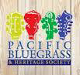
BEACOnSPRING 2018

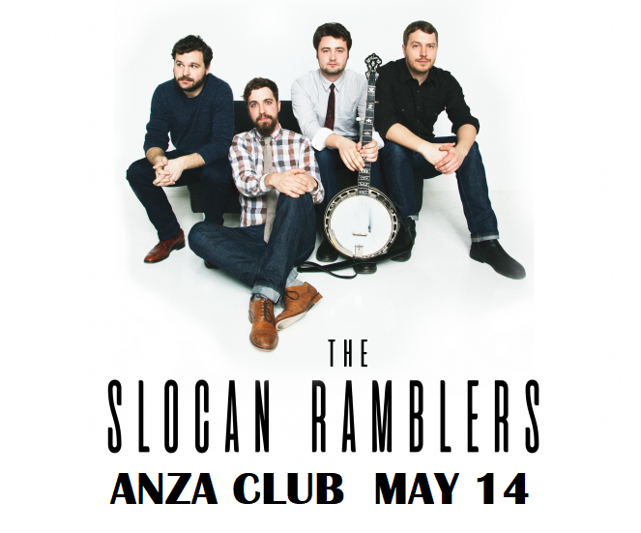

Interview With Sue Malcolm B.C’s Queen of Bluegrass
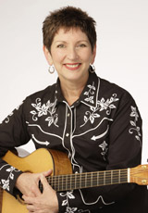

BB: How did you get started in bluegrass Sue?

SM: I learned to play guitar when I was in my early twenties. I had some friends who played at various folk clubs around town but I just started by playing music at home to entertain my kids. I learned folk music and I got really involved in the Vancouver Folk Song Society, which is still going. They focus on folk singing, not so much the instrumental thing. I got involved in the organization and was part of a committee that ran the Green Cove Coffee House at Britannia. Different touring acts would come, and It was a lot like the house concerts people are having today. A group came in from Bellingham called The Sandy Bradley String Band, and they played really hot old time music- frailing banjo, fiddle and guitar. They played fast and really energetically and I was knocked out by them. There also was a local guy named Barry Hall, a fantastic guitar player who also was a great banjo player, who played Scruggs style and he played at the coffee house a few times and he got me excited about bluegrass. He was a prodigy who recorded an album for Folkways when he was seventeen years old. Barry was also an artist and he had a tremendous influence on me because I ended up joining a band that he was the leader of. The band was called The Other People, because we thought we were outcasts from the Folk Song Society. We then decided that we would go off and form our own association. That’s when I met Keith Malcolm, who I married, as he was the fiddle player in the band, and, almost immediately I was singing and performing in public. I couldn’t really play the guitar well enough to keep up so I played the auto-harp. It was sort of like a jug band with a lot of people playing in it.
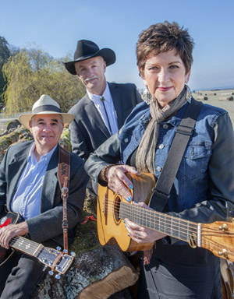
BB: Can you tell us more about how the bluegrass association got started?

SM: In 1980 Peter Thompson and Paul Norton, who is my partner now, were both programmers at CO-OP Radio and they got the word out through their program-Radio Ranch- that there was a group of people who were interested in getting together to play bluegrass. Peter Thompson announced on the radio that there was going to be a jam at Jericho Beach and anyone interested in playing should meet at the concession stand, and a big crowd of people showed up. There were other key people: Michael Brooks, a mandolin player, a guy named Don Mallais who played banjo, Jake Devilliers who repaired instruments, and Allan Richardson, an instrument builder who ended up being the first president of the club. We had informal meetings and formed a society. Bluegrass was something new and fresh and cool and it just got us really excited.
THE SODA CRACKERS

BB: Where did the club go after the jams at Jericho Beach?

SM: We had our first meeting at the Alfa Café in the summer of 1980and met at a number of other places including the UBC Rugby Club, and a back room behind Jerry’s Cove. Then Garry Crystal, the director of the Vancouver Folk Festival, asked us if we wanted to use the Soft Rock Café on Monday nights, as he was in charge of bookings there. It had a stage and a back room, so we paid for some baffles to divide space up because the back room area was huge. Then we started having shows with open stage and local bands. Later on Garry Crystal approached us again and asked if we wanted to co-produce a big concert. We’d never put on a concert by an authentic bluegrass band so we said sure and the concert he offered us was Bill Monroe and The Blue Grass Boys.

BB: What do you remember about the concert?

SM: The excitement. I knew Bill Monroe was a big deal. I had heard some of his recordings but I’d never heard any established bluegrass band live. Peter Thompson from CO-OP radio was the MC and I can still remember the feeling when they started to play- the energy was like a freight train coming at you. It was an unbelievable amount of energy and drive. The crowd’s response was crazy because this was the first live bluegrass band many of them had seen.

BB: Did you get a chance to speak to Bill Monroe at all?

SM: Yes. I remember him being very serious about his music. He lived for it. He loved to perform. He loved to be with people. You get a lot of artists that come to town and say wow Vancouver is a beautiful place but there was none of that. It was all about the music.

BB: What did he say about the music?

SM: He owned it- “When I invented bluegrass”. He was in charge. He dominated the stage. The show was a show, very tight. He was a larger than life personality for sure. Very professional. Didn’t get into any small talk. It was so amazing to be there really.

BB: Let’s switch tracks here a little. What about being a female in bluegrass? Who do you see as your mentors?

SM: I was really influenced by Emmy-Lou Harris. She was the first woman that I was aware of that was doing bluegrass music or anything related to it, and of course she has branched off into many different areas. There are a lot of songs in bluegrass that can’t be sung from a woman’s point of view unless you change the lyrics, so the songs that she sings are ones that do work. Another big influence on me has been Hazel Dickens and Alice Gerrard. They put out a series of recordings of bluegrass duets and old time songs. They were fabulous singers singing fabulous songs and they surrounded themselves with great instrumentalists.

BB: Is there something beyond gender that you are connecting to in bluegrass?

SM: To me it all comes down to community and the connection to people. I’ve never aspired to be a solo performer, for instance. I’ve always gone for groups because I want that spirit. I believe that’s one of the secrets of the success of the slow pitch jams. All the teaching I do is in a group format. Everything I do in my life is about building community. Fostering community is something I can do.

BB: As a teacher of bluegrass can you talk a little about general concepts that will help people play better.

SM: It does take a lot of time to learn how to play a stringed instrument because of all the multi-tasking that you have to do. Especially if you start as an adult be patient with yourself. Don’t expect to be playing hot licks. Don’t go too fast. That’s why the Slow Pitch Jams are so good as they help people develop a solid skill base, at a reasonable tempo. People get frustrated and quit because they can’t play like Tony Rice in six weeks. If people want to learn to play good bluegrass they have got to listen to good bluegrass and really kind of analyze what’s going on. Study what each instrument is doing, and try to go for that sound.
BB: Are there specific recordings you recommend people listen to?
SM: You have to say Bill Monroe And The Blue Grass Boys, but there is a series of recordings that came out in the eighties by the Bluegrass Album Band and I use them now in my night school classes when I play little excerpts of things to illustrate to people really good playing. This is what they call the second generation of bluegrass players. I think they really nailed the sound and the feel of all the standards but it was a higher quality of recording than Bill Monroe or Ralph Stanley.
BB: Any advice for singers?
SM: Yah, do it! People are shy so they need to build their confidence. I like to sing songs that resonate with me in some way and to deliver the song with some authenticity. People need to figure out where their vocal range is. Singing in a choir really helps. Then just do it. Group support is really great.
BB: What kind of songs do you like to sing?
SM: I like songs that are bluesy. A lot of Bill Monroe songs have a blues quality. I like Blue Night and Rocky Road Blues. I like bluesy and jazzy and western swing.
BB: Thanks a lot for taking the time to speak with us today Sue and thanks for being part of the crew that started the club.
SM: Oh you’re welcome. See you at the Slow Pitch.

PRESIDENTS MESSAGE
With spring on the way, we are looking forward to sunny days and warm weather in the months to follow. At PBHS we are looking forward to lots of good times at the ANZA with Sue Malcolm’s slow pitch jam on the first Monday of every month. I certainly enjoyed reading the interview with Sue in this issue and fun to hear about our Club’s history.
Our old time jams continue to be a hit, with a dedicated group of old time musicians seen seated in a circle on the main floor of the ANZA on the third Monday of each month.
We will have two more open stage performances this year before we head off to Trout Lake for the summer, with the March 12th performance already full! It may not be too early to consider performing on June 25, which will probably be here before you know it…
Our AGM is scheduled for April 30, 2018, which will include a special presentation by Sue Malcolm about a potential one-day festival…stay tuned for more info. Everyone is encouraged to come out and hear about what our club is doing and share your ideas. We will also be electing our board of directors at that time, and always welcome new candidates to step up and join the board.
We are looking forward to a great concert on Monday, May 14th with the Slocan Ramblers, with our very own Stardust String Band as the opening act…Hope to see you all there.
Keep pickin’
Fran
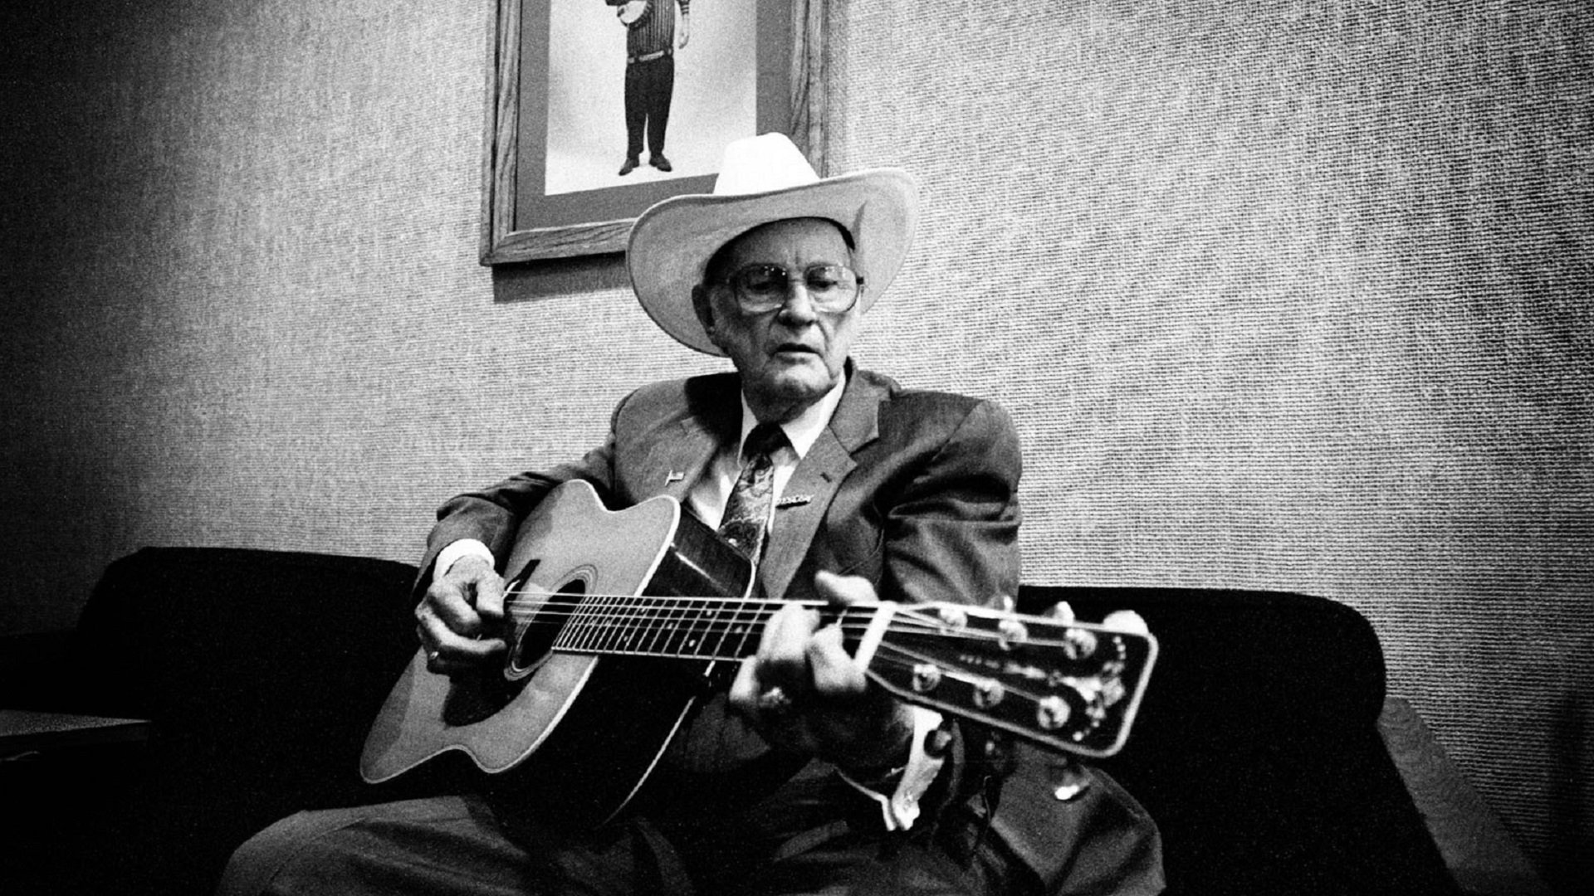

IN THE BEGINNING
THE BILL MONROE
CONCERT
November 3rd 1980

Years before moving to the Bay Area, broadcaster/promoter/producer and long time supporter of bluegrass, Peter Thompson was part of Vancouver Co-op radio’s

First country show entitled “Back in the Saddle”. Listeners convinced Peter that we needed a more active live bluegrass scene in Vancouver, and that this could be realized by booking bands on Monday nights who were playing weekend gigs south of the boarder. At the same time our club was in its infancy, with charter members including Peter, Alan Richardson and his then wife Louise, Don Mallais, Sue Malcolm, Alan Wood, Dave Lidstone, meeting at Alan’s place, deciding on the name and establishing jams at the Soft Rock on West 4th.

Meanwhile back in radio-land, Peter began to mentor Garry Crystal, as Garry wanted to promote the Vancouver Folk Festival, which they did by creating the “What the Folk” program. Garry then asked Peter if the brand new “Pacific Bluegrass and Heritage Society” wanted to co-present a Bill Monroe and the Blue Grass Boys concert at the Soft Rock. It was Sue Malcolm’s description of this very concert that first put me onto Peter’s trail. This, in turn, led me to Peter’s article about the founding of the club, and more recently to an email exchange with Peter about the show itself. What follows is his description of the night Big Mon came to town.

“I remember an absolutely thrilling show. Monroe was in fine form, Kenny tore it up, and the then-recently-added band members gave the old chestnuts some new life. The audience for both shows went nuts, cheering after the first vocal trio as well as many of the solos, and requesting songs that they never thought they'd experience live. There had been very few performances by any US bluegrass bands (never mind The Father Of BG) up to this point — and I think Bill told me that he’d never before played in BC. Mark Hembree said after the show that Monroe had been quite moved by Vancouver’s response, and he did seem to love not only the applause but also the participatory singing. It was also thrilling for me to get to MC (for the first time!) the show and to interview Bill between sets. And it surely launched the PB&HS in fine fashion. Talk about starting at the top …”
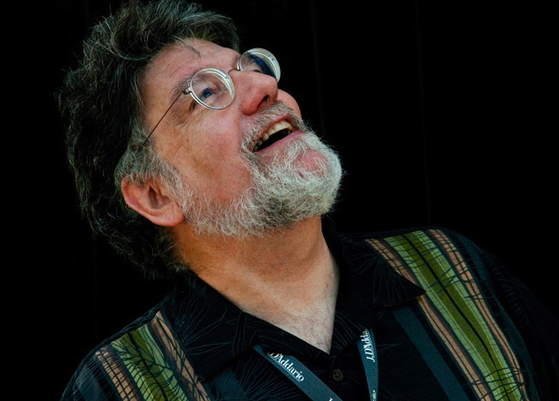

Bluegrass, impresario and founding
member, Peter Thompson

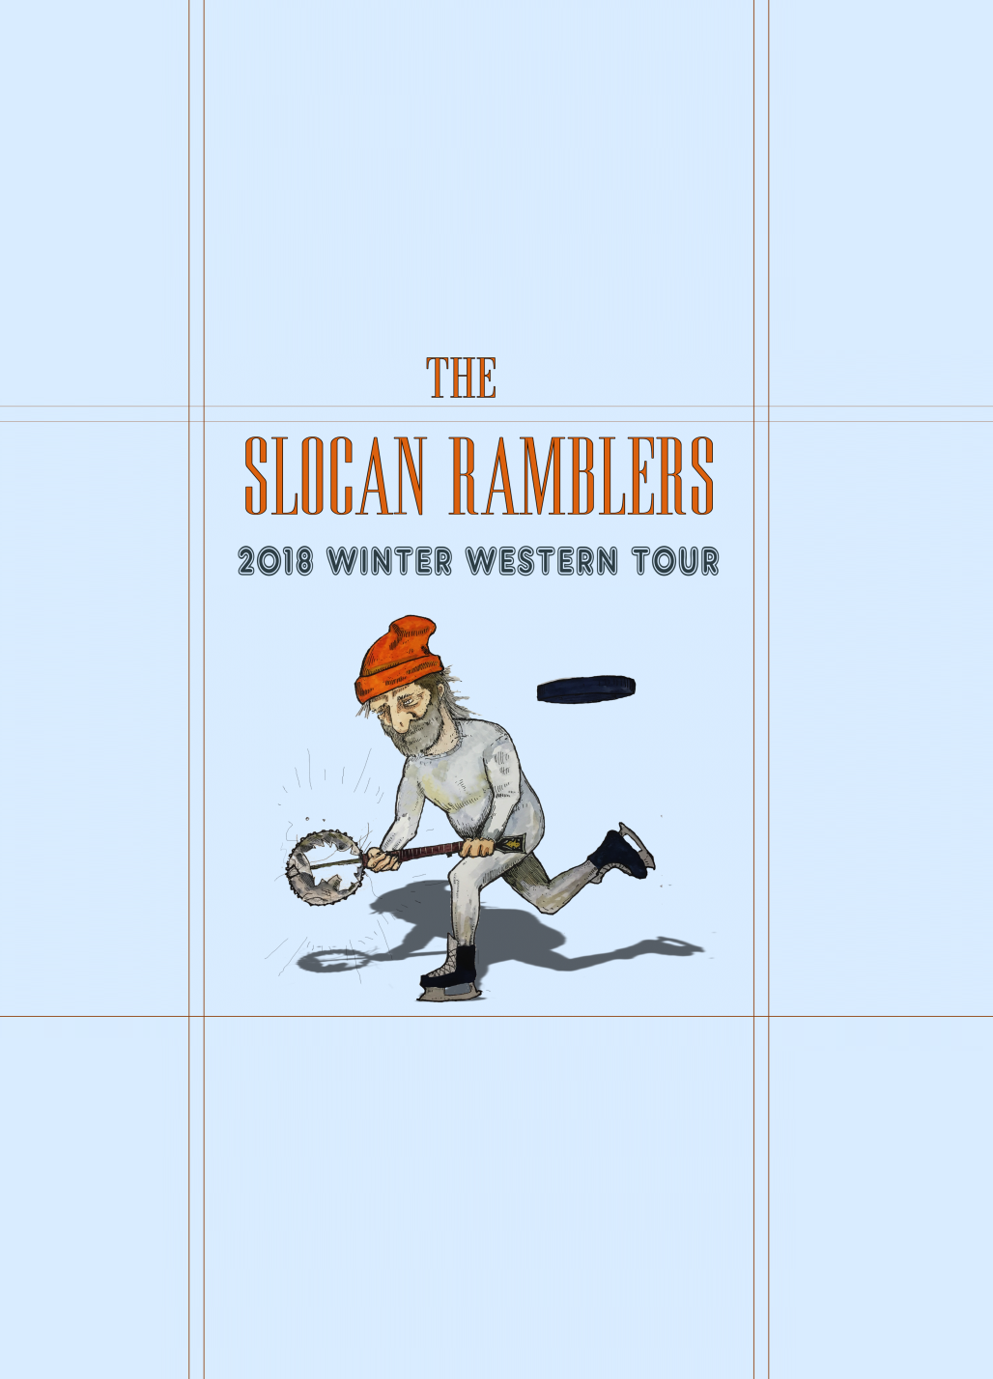

There’s a fresh breeze comin’ down from the mountains and they’re called The Slocan Ramblers. They are young and hip but don’t think for a second that these guys are not a traditional bluegrass band. Singer and banjo player Frank Evans has a big voice and the kind of chops that are reminiscent of his namesake, the late, great Dave Evans. Guitar picker Darryl Poulsen creates all kinds of instrumental fireworks when he cuts loose and mandolin player/arranger Adrian Gross always keeps things interesting. Filling out the bottom end and keeping the party rocking is Alastair Whitehead on stand-up bass. These guys are not to be missed. Opening for the Slocan Ramblers will be the Stardust Stringband.

Live at the Anza May 14th

